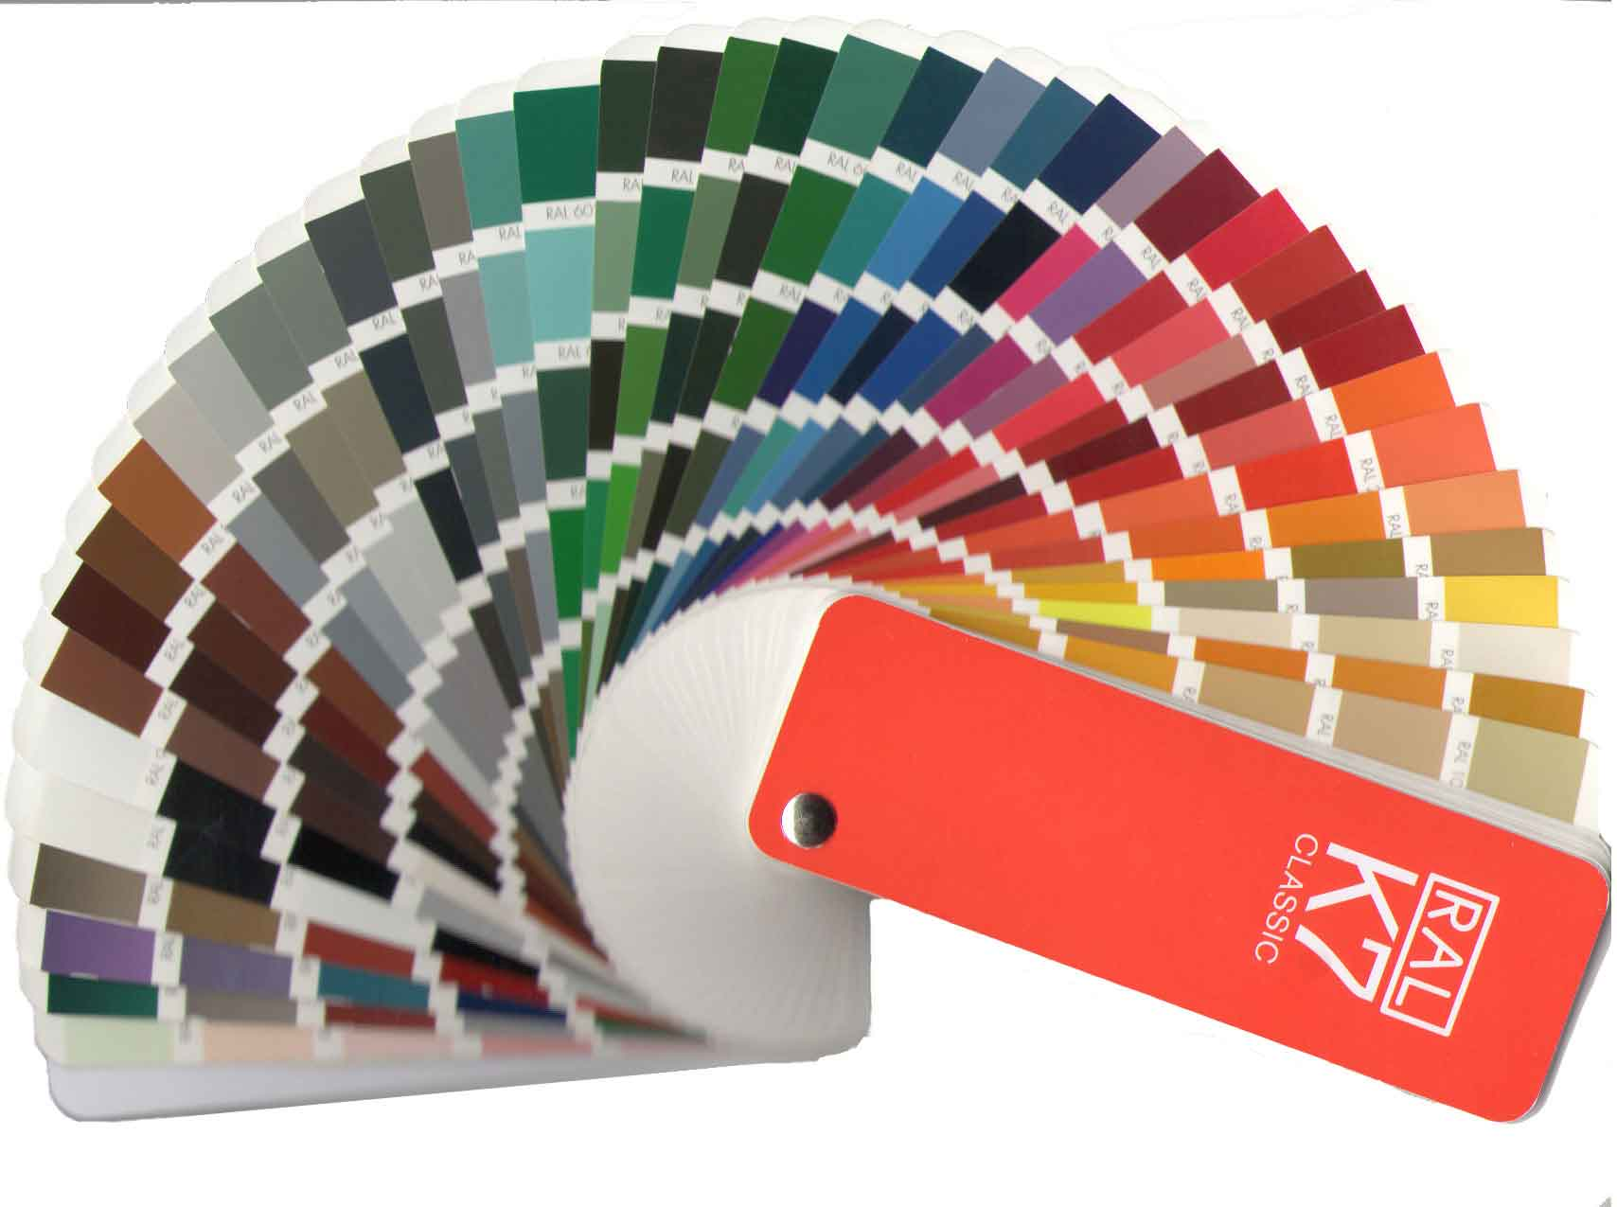

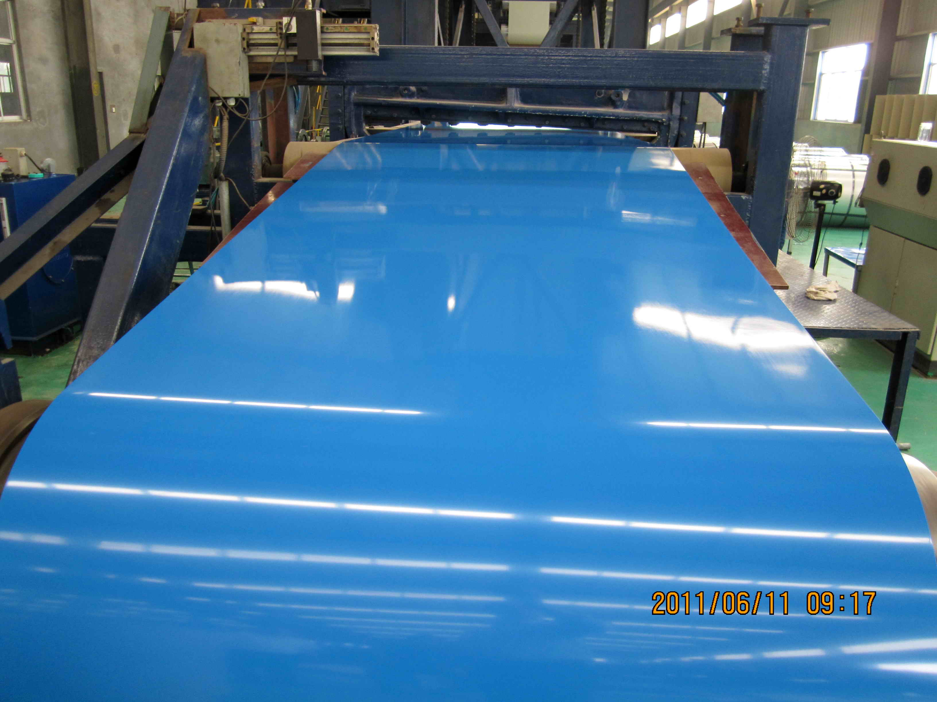

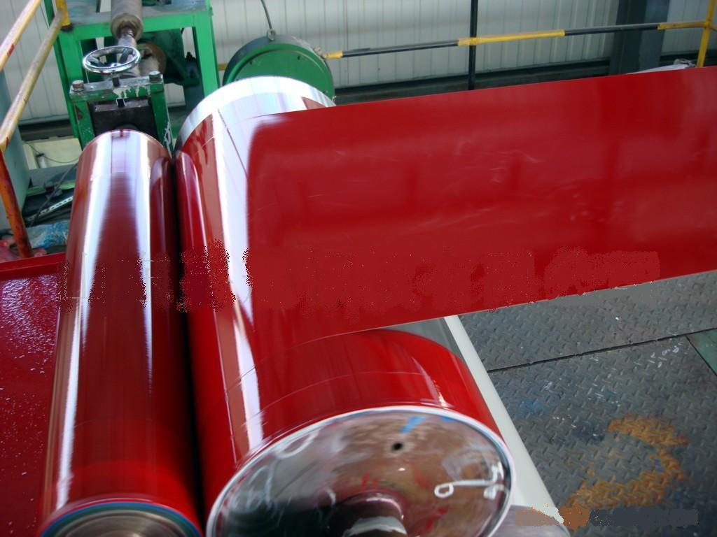

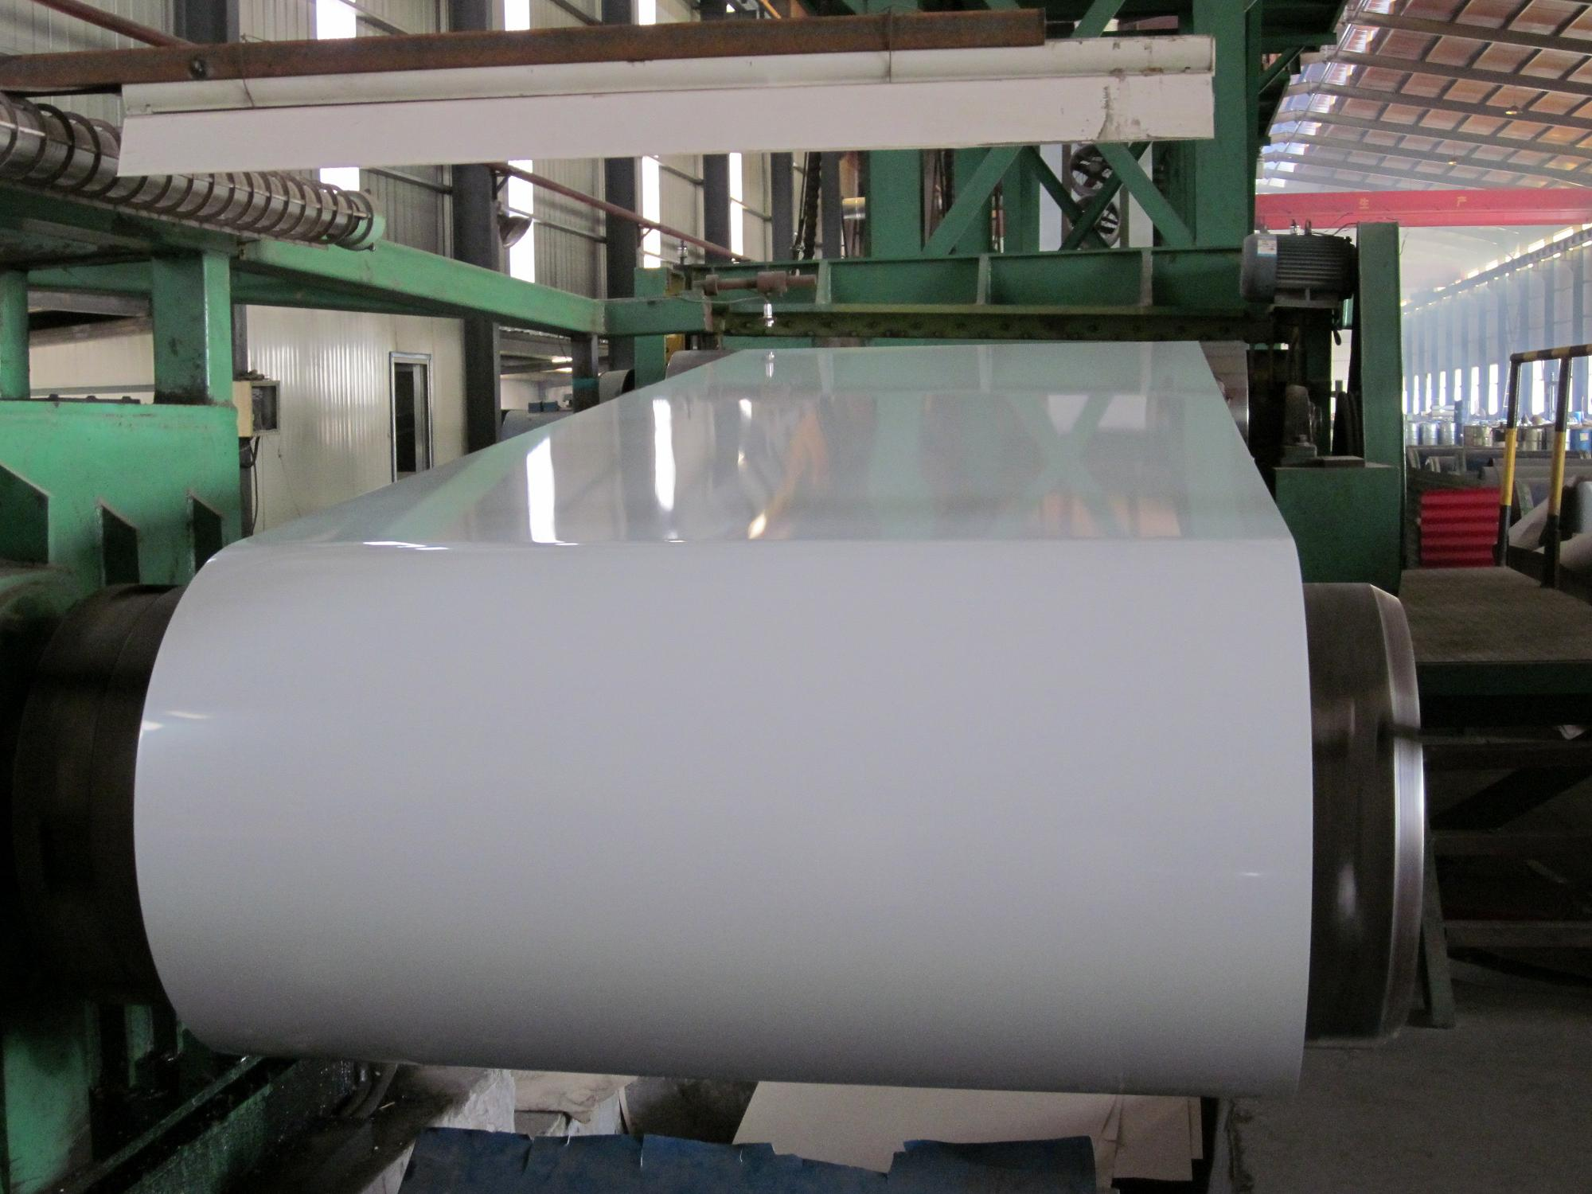

Nobleagle Trade & Investment Ltd
Mobile: 0086-133-0844 9055
yen (at) nobleagle (.) com

Pre-Painted Hot Dipped Galvanized Steel

PPGI is prepainted galvanised steel, also known as precoated steel, coil coated steel, color coated steel etc. A galvanised steel sheet in coil form is cleaned, pretreated, applied with various layers of organic coatings which can be paints, vinyl dispersions, or laminates.These coatings are applied in a continuous process known as Coil Coating.The steel thus produced in this process is a prepainted, prefinished ready to use material. PPGI is the material which uses galvanised steel as the basic substrate metal. There could be other substrates such as aluminum, Galvalume, stainless steel, etc.
Basic Substrate: Cold rolled HDG / Galvalume
Color Standard: Acc to Ral Color Standard or customer's color sample
Thickness : 0.23mm-1.2mm
Zinc spangle : Regular, Minimum
Width : 1000mm-1500mm
Surface Treatment : Bright/Matt Finishing
Zinc Weight : 60g/m2-200g/m2
Coil Weight : 3 MT-10 MT
I.D : 508mm/610mm
Painting Materials : PE/SMP/PVC/PVDF
Standard :
GB/T12754-06 : TDC51D+Z TDC52D+Z TS250GD+Z TS280GD+Z TS320GD+Z TS350GD+Z
JIS G 3312 : CGCC CGCD
EN 10169 : DX51D+Z DX52D+Z S250GD+Z S260GD+Z S320GD+Z S350GD+Z
Applications:
Outdoor: roof, roof structure, surface sheet of balcony, frame of window, door, garage doors, roller shutter door, booth, Persian blinds, cabana, refrigerated wagon and so on.
Indoor: door, isolators, frame of door, light steel structure of house, sliding door, folding screen, ceiling, internal decoration of toilet and elevator.

We respect the time of our buyers and expect the same. When sending your inquiries, please provide us with your detailed requirements as below for proper quoting:
- Company name
- Company address, e-mail, address, and website
- Product name
- Steel Quality and Grade
- Size, length
- Quantity per size and total
- Payment term
- Invoicing (Actual or Theoretical Weight Basis)
- Preferred method of delivery (FOB,CFR)
- Destination port (Even for FOB deliveries)

Nobleagle Trade & Investment Ltd
Tel: 0086-133-0844 9055, 0086-21-5109 7292
E-mail: yen@nobleagle.com
MSN: paulyen83@hotmail.com
SKYPE: paulyen83
Website: www.nobleagle.com

