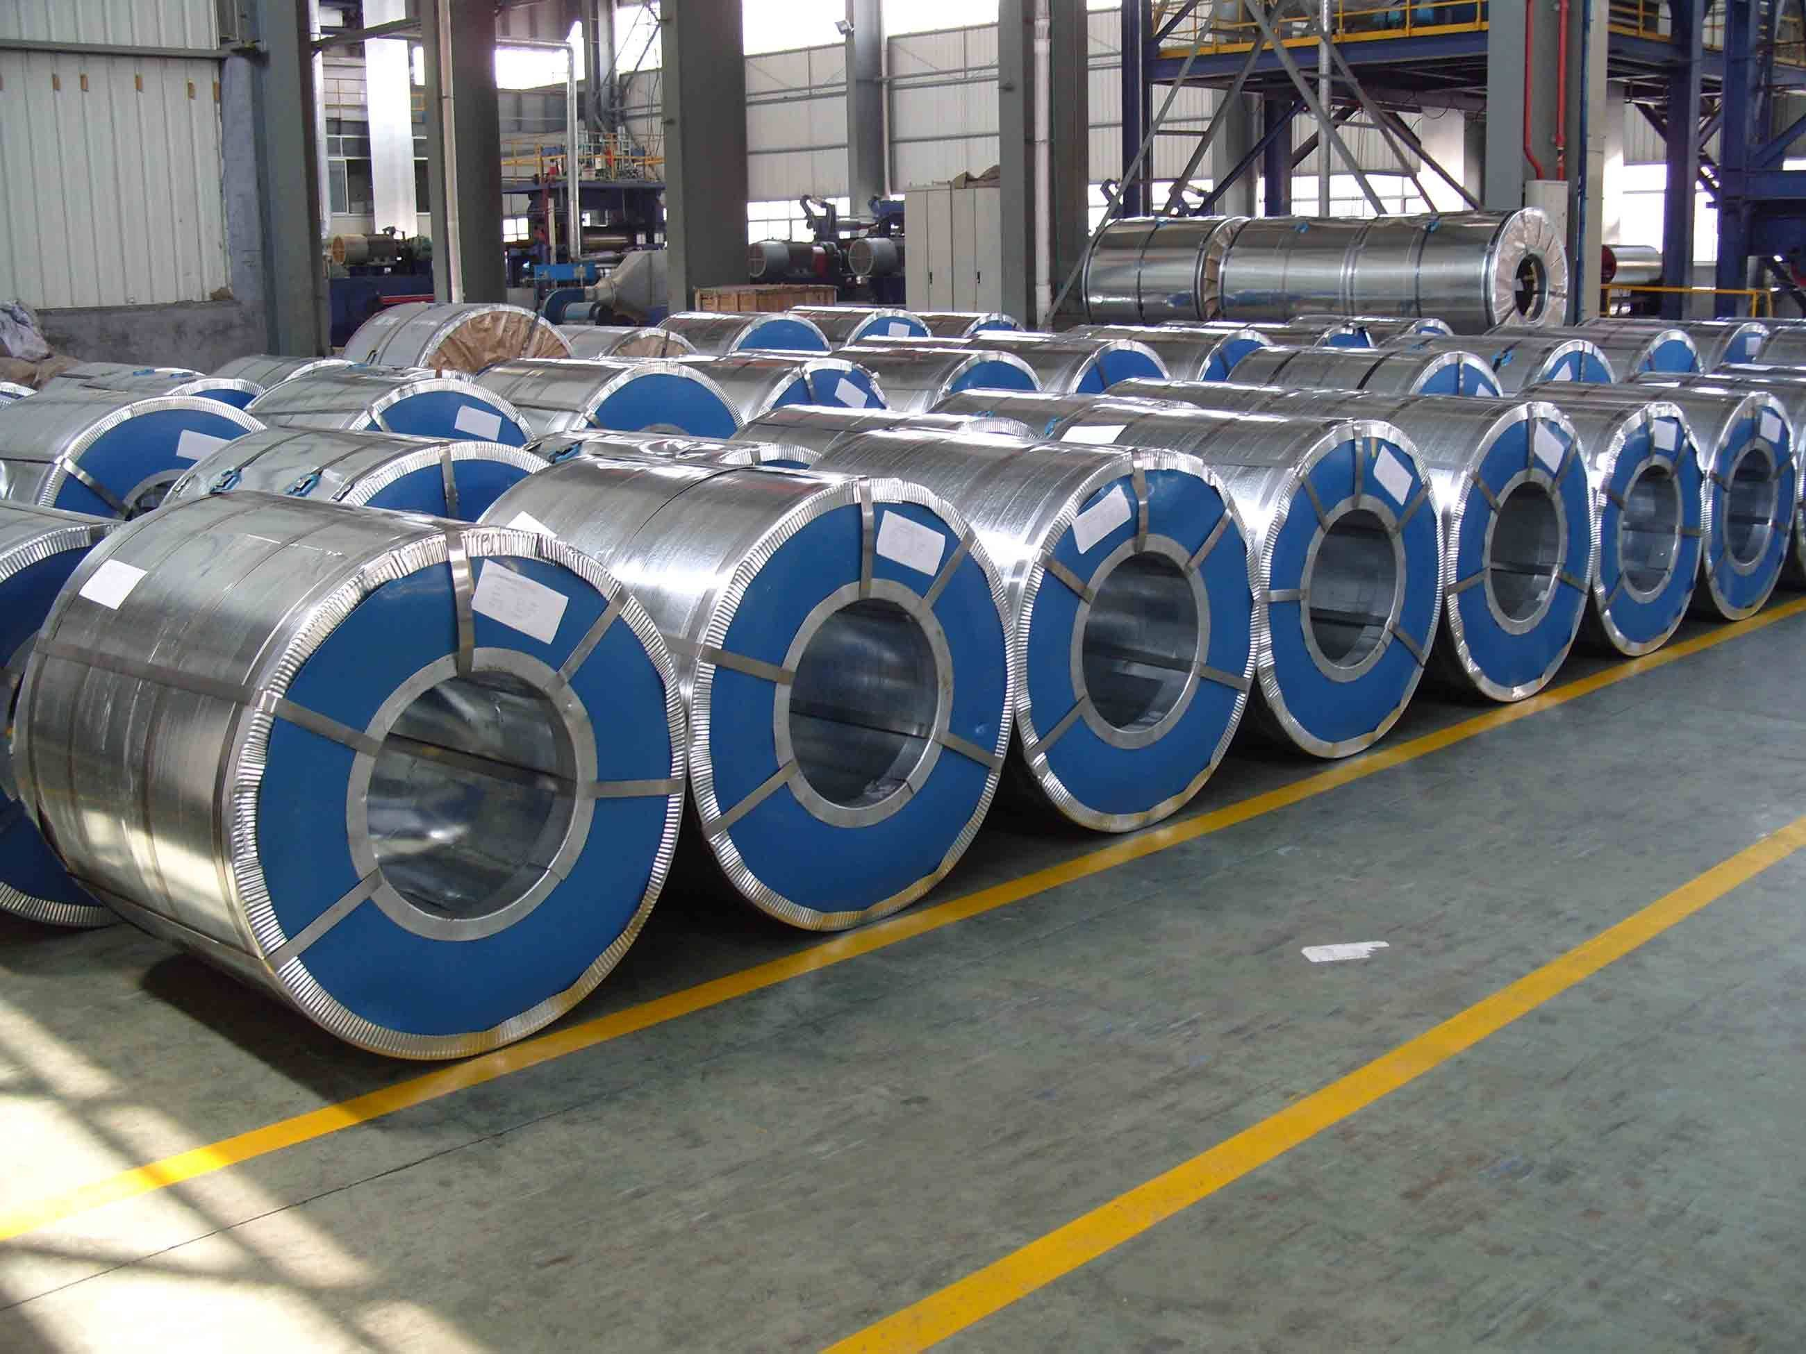

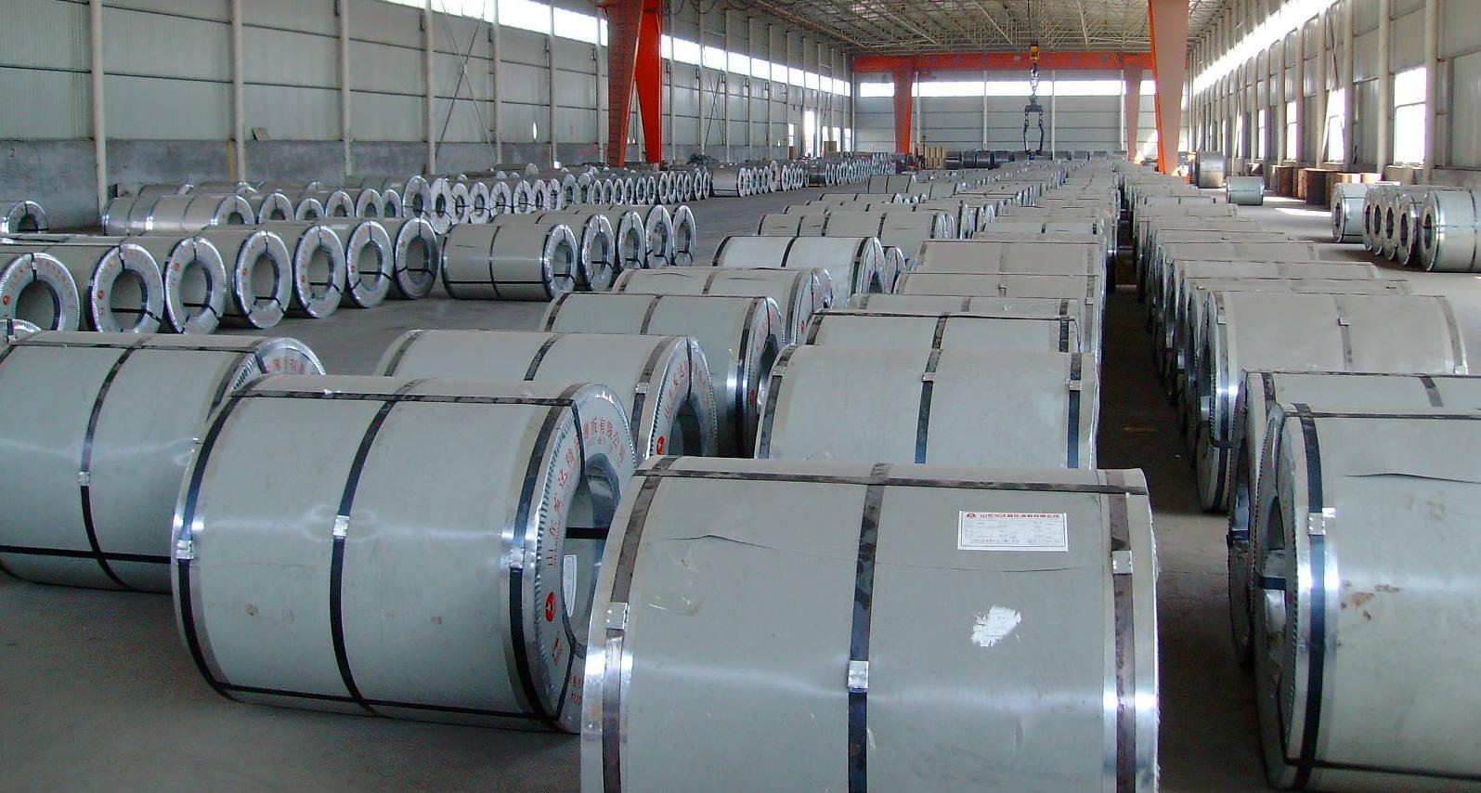

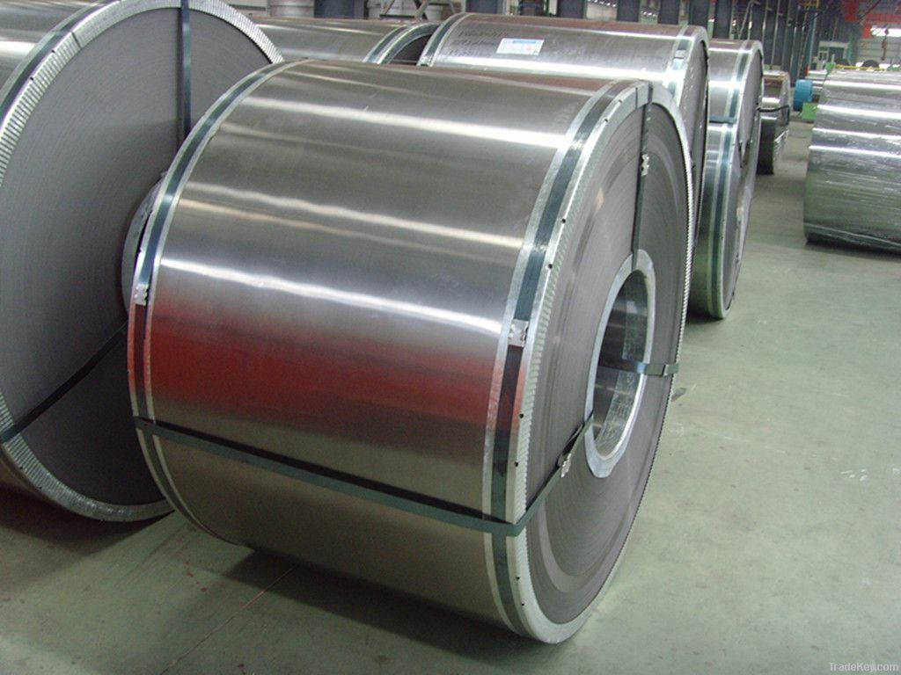

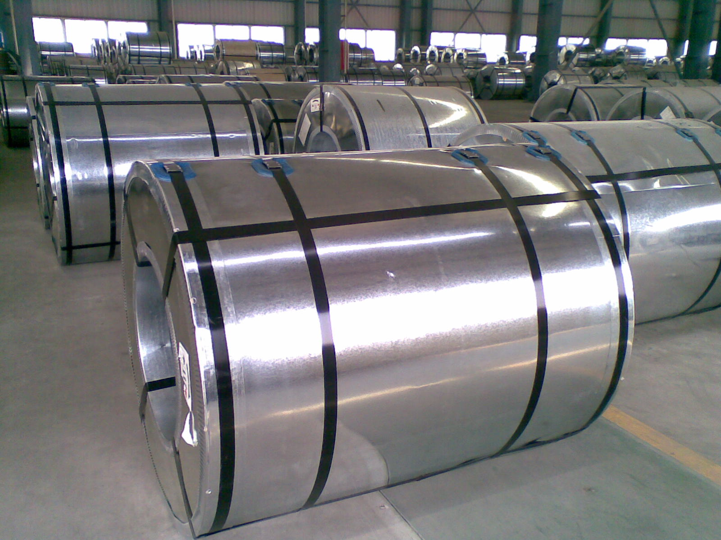

Nobleagle Trade & Investment Ltd
Mobile: 0086-133-0844 9055
yen (at) nobleagle (.) com

Hot dipped Galvanized steel

Galvanized steel is to prevent to steel coil surface from corrosion and prolong the service life of the steel coil, coated with a layer of metal surface zinc zinc coating, the thin plate called Galvanized steel.
According to production and processing method can be divided into the following categories:
(1) The hot dipped Galvanized steel. Will thin plate into fusible zinc slot, make its surface adhesion a layer of zinc Galvanized steel. At present the main USES continuous galvanizing technology production, namely volumes of Galvanized steel continuous leaching of zinc plated fuses in a tank is made of zinc-plated Galvanized steel;
(2) The alloying Galvanized steel. This kind of Galvanized steel is to use a hot leaching manufacturing, but in the slot, immediately after it heated to 500 °C or so, make its generation of zinc and iron alloy is film. This kind of galvanized sheet has the good coating the secret of sex and welding sex;
(3) The electricity Galvanized steel.

Standard : ASTM A653, JIS G3302,GB/T3830-2006
Grade : DX51D,SGCC,SPCC,SGHC, SGCC, SGCH, SGCD1-SGCD3, SGC340-SGC570
Thickness : 0.2-4.5mm
Width : 1000-1500mm(usual size: 1000mm,1200mm,1219mm,1250mm,1500mm)
Zinc coating : 30-275gsm
Coil ID : 508mm&610mm
Packing : Standard seaworthy export packing: 3 layers of packing, inside is Kraft paper, water plastic film is in the middle and outside GI steel sheet to be covered by steel strips with lock, with inner coil sleeve.
Payment terms : L/C at sight or T/T
SURFACE TREATMENT of galvanized steel coil :
Mini/regular/big/zero spangle, Chromate treatment /chromate-free treatment /untreated unoile/oiled ,TENSION LEVELLERT SKIN PASS anti-fingerprint/un-anti-fingerprint ,Coating
APPLICATION of galvanized steel coil : Structural use ,roofing, commercial use, household appliance, industry, family

We respect the time of our buyers and expect the same. When sending your inquiries, please provide us with your detailed requirements as below for proper quoting:
- Company name
- Company address, e-mail, address, and website
- Product name
- Steel Quality and Grade
- Size, length
- Quantity per size and total
- Payment term
- Invoicing (Actual or Theoretical Weight Basis)
- Preferred method of delivery (FOB,CFR)
- Destination port (Even for FOB deliveries)

Nobleagle Trade & Investment Ltd
Tel: 0086-133-0844 9055, 0086-21-5109 7292
E-mail: yen@nobleagle.com
MSN: paulyen83@hotmail.com
SKYPE: paulyen83
Website: www.nobleagle.com

