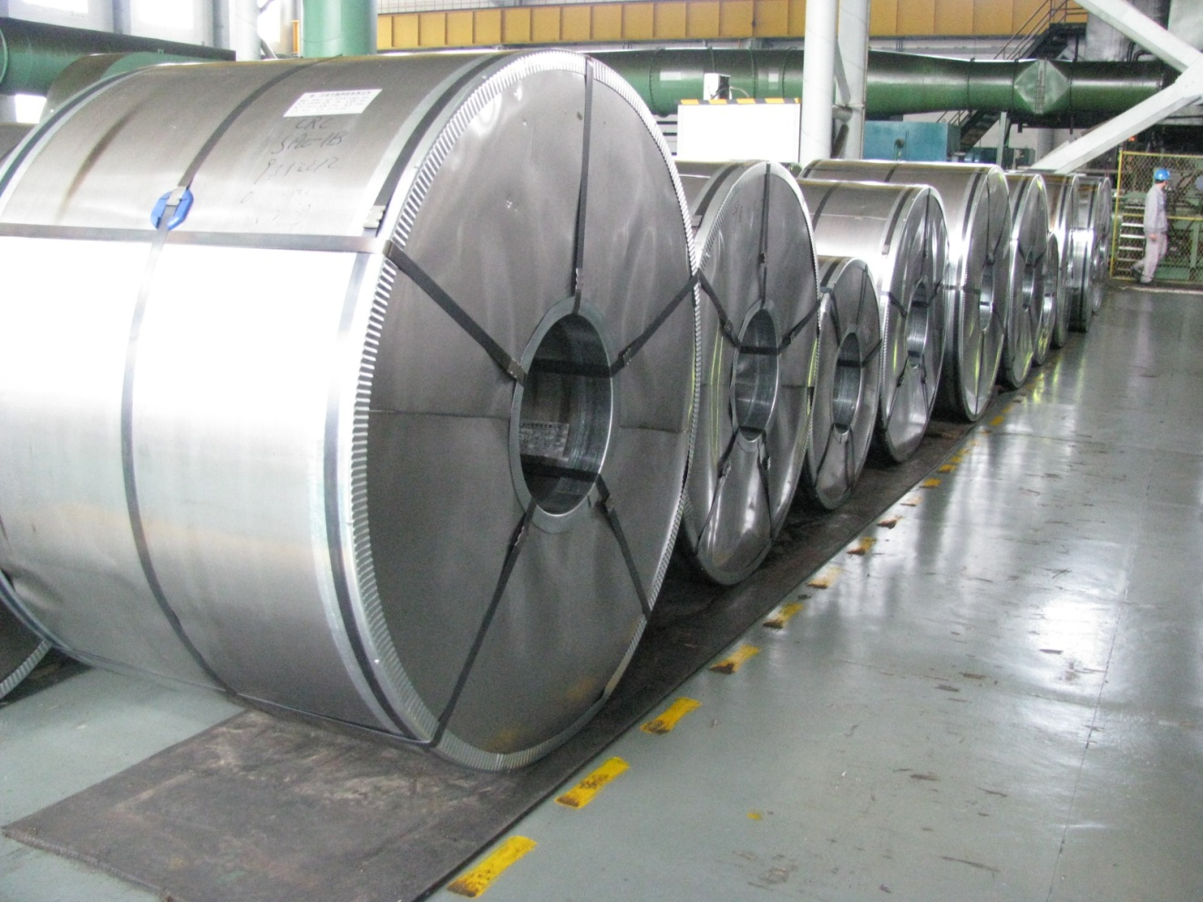

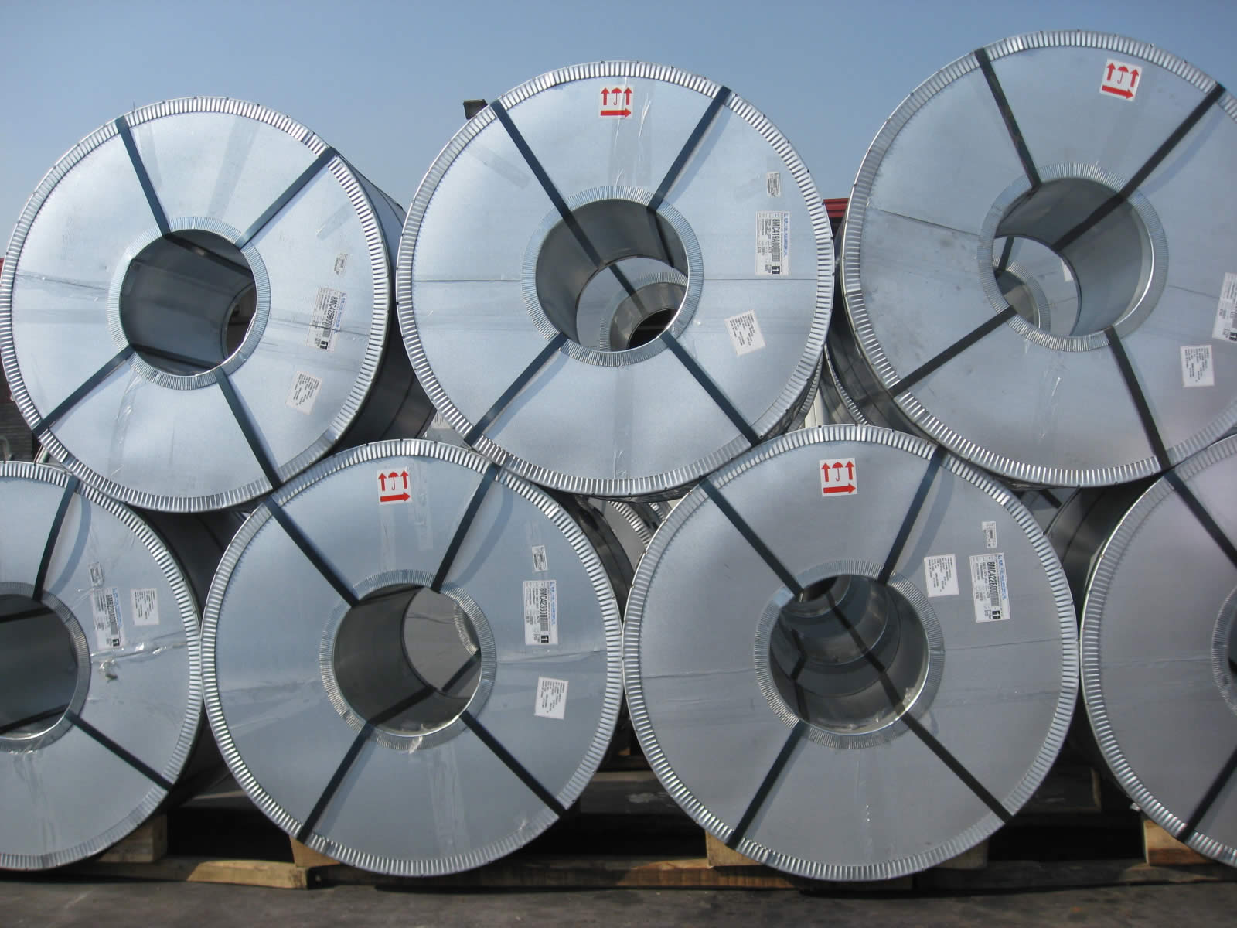

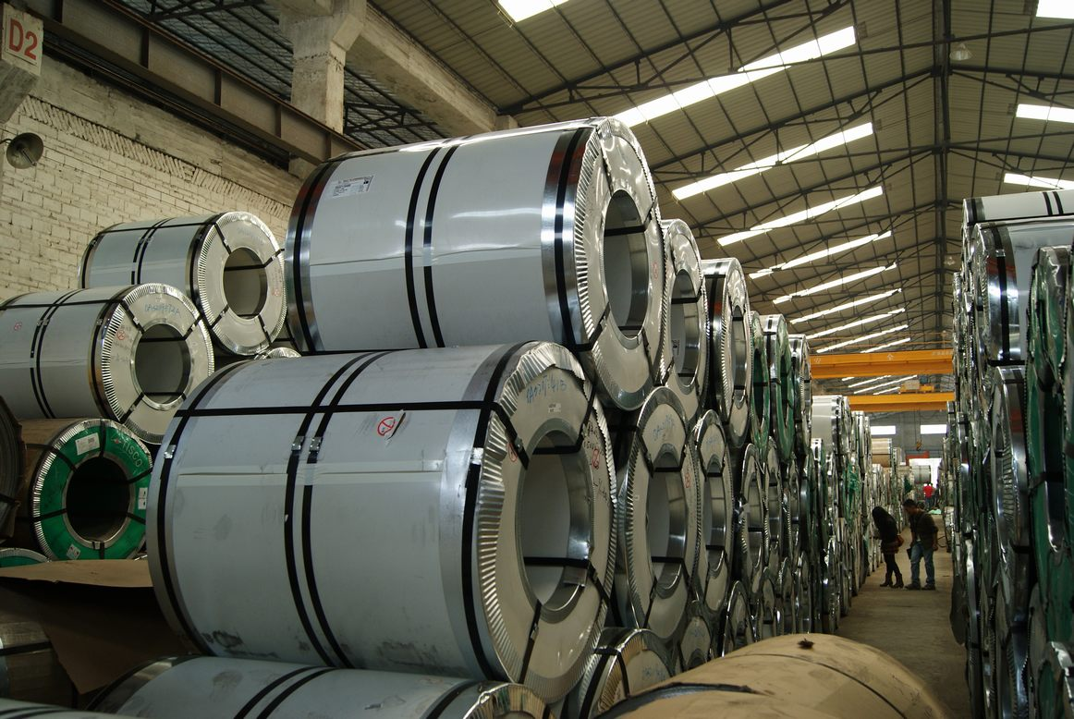

Nobleagle Trade & Investment Ltd
Mobile: 0086-133-0844 9055
yen (at) nobleagle (.) com

Products Name: Cold Rolled Steel Sheet in Coil
Standard & Grade:
GB11253-89 Q195 Q235
JIS G3141 SPCC SGCC SPCD SPCE
DIN1623 ST12 ST13 SPCD ST14
EN10130 DC01 DC02,DC03
Thickness : 0.18-3.5mm
Width : 1000mm-1500mm or 1000/1200/1219mm/1250mm
Surface Finish : General, bright, dull and mirror finish, oiled or non-oiled
Coil ID : 508mm
Coil weight : 5-15 tons
Packing : export packing or as client's requirement
Certificate : ISO9001:2008
Application
1. Common structural parts and parts for drawing in engineering machines
2. Transportation machine construction machines, lifting machine,
3. Agricultural machines, light and civil industrial, household appliance industries.
4. Chemical equipments, drive casing pipe and light industrial civil industries.

We respect the time of our buyers and expect the same. When sending your inquiries, please provide us with your detailed requirements as below for proper quoting:
- Company name
- Company address, e-mail, address, and website
- Product name
- Steel Quality and Grade
- Size, length
- Quantity per size and total
- Payment term
- Invoicing (Actual or Theoretical Weight Basis)
- Preferred method of delivery (FOB,CFR)
- Destination port (Even for FOB deliveries)

Nobleagle Trade & Investment Ltd
Tel: 0086-133-0844 9055, 0086-21-5109 7292
E-mail: yen@nobleagle.com
MSN: paulyen83@hotmail.com
SKYPE: paulyen83
Website: www.nobleagle.com

