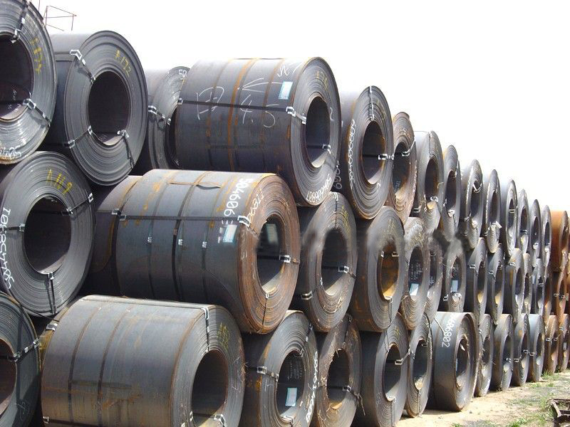

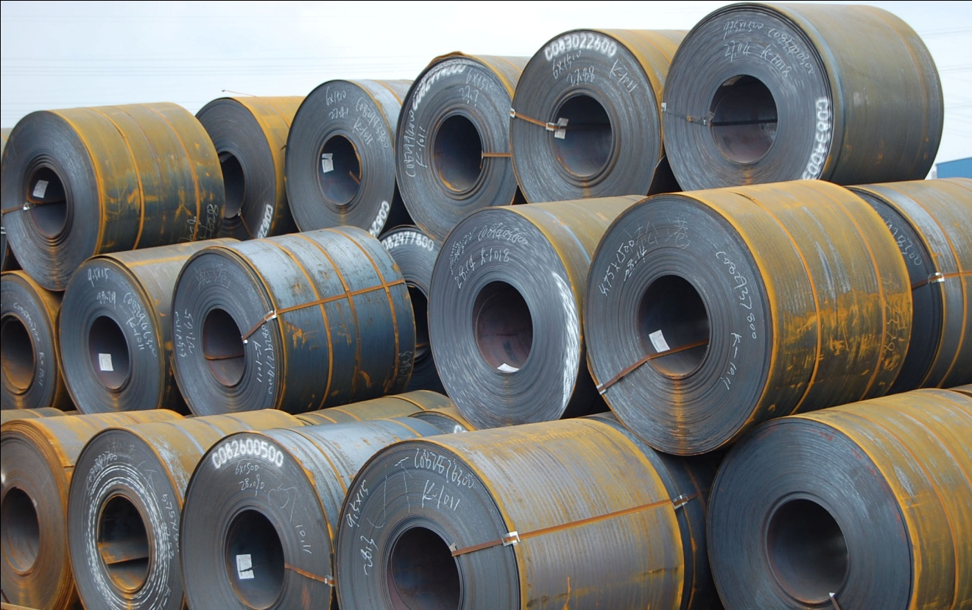

Nobleagle Trade & Investment Ltd
Mobile: 0086-133 0844 9055
yen (at) nobleagle (.) com

Product Name: Hot Rolled Steel Coil
Specification
Width: 1000-2000mm
Thickness: 1.20-25.00mm

Hot Rolled Steel for General Structures
Steel for general structures and welded structures are produced for steel structures, bridges, ships, and automobiles.
JIS: SS330, SS400, SS490, SM490A, B, C
ASTM: A36,A283,A570
DIN: DIN17100 ST52-3, RST37-2

Steel for Cold Rolled Steel Sheet
This cold-rolled sheet is used in many cold-rolled products, such as CR, GI, and color plates.
SAE: SAE1006
JIS: SPHC

Steel for Tubes
Excellent in weldability and formability, this steel is quite versatile with its uses in structural pipes, general pipes, special pipes, and carbon steel pipes for machines.
JIS: SPHT 1, 2, 3, 4,

Steel for High-Pressure Gas Cylinders
Superior in formability and pressure resistance capacity, this steel is used in high-pressure gas containers with the inner capacity to hold less than 500 liters of LPG, acetylene, and other high-pressure gases.
JIS: SG255, 295, 325, 365

Steel for Oil Well Pipes
This high-quality steel is used for drilling in extremely cold regions and deep sea oil wells since this steel is marked by its extremely low temperature toughness, high weldability, and excellent fracture resistance.
API: 5CT-H40, J55, K55, N80

Steel for Pipelines
This steel makes excellent pipeline material because of its strength, extremely low temperature toughness, hydrogen-induced crack resistance, and weldability.
API5L: A, B, X42, 46, 52, 56, 60, 65, 70, 80

We respect the time of our buyers and expect the same. When sending your inquiries, please provide us with your detailed requirements as below for proper quoting:
- Company name
- Company address, e-mail, address, and website
- Product name
- Steel Quality and Grade
- Size, length
- Quantity per size and total
- Payment term
- Invoicing (Actual or Theoretical Weight Basis)
- Preferred method of delivery (FOB,CFR)
- Destination port (Even for FOB deliveries)

Nobleagle Trade & Investment Ltd
Tel: 0086-133-0844 9055, 0086-21-5109 7292
E-mail: yen@nobleagle.com
MSN: paulyen83@hotmail.com
SKYPE: paulyen83
Website: www.nobleagle.com

